

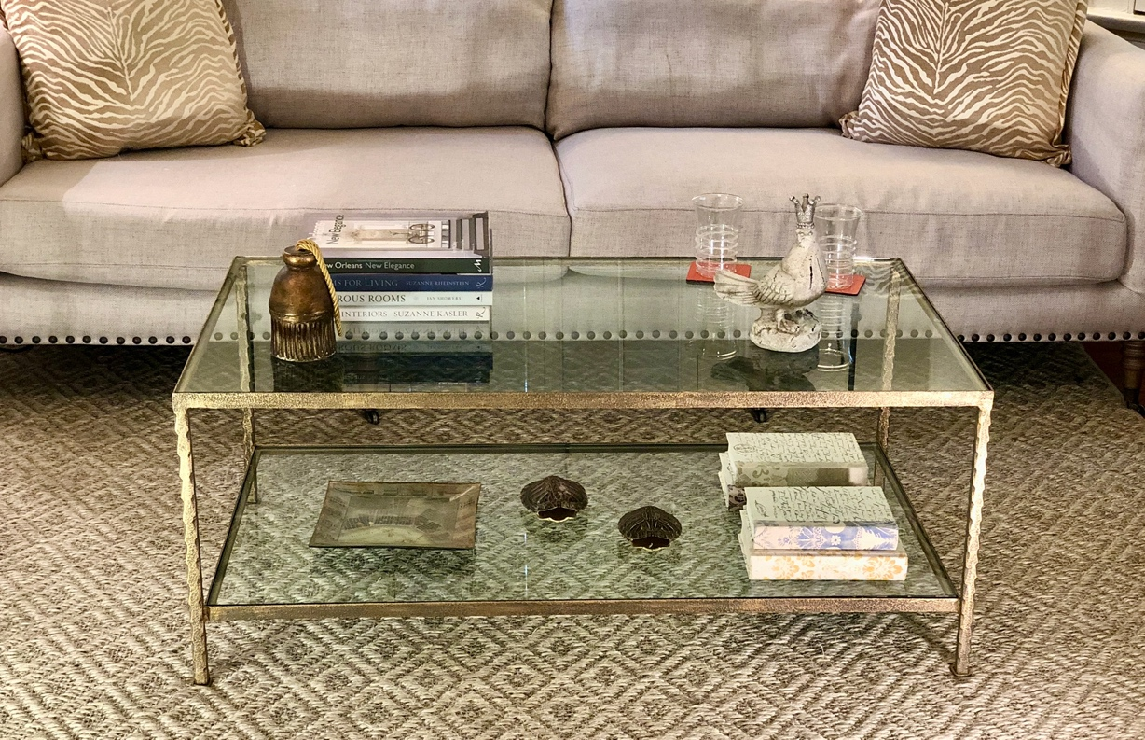

Lowerline Coffee table – shown in aged gold finish with clear glass top

available in all finishes 