Louis Bench

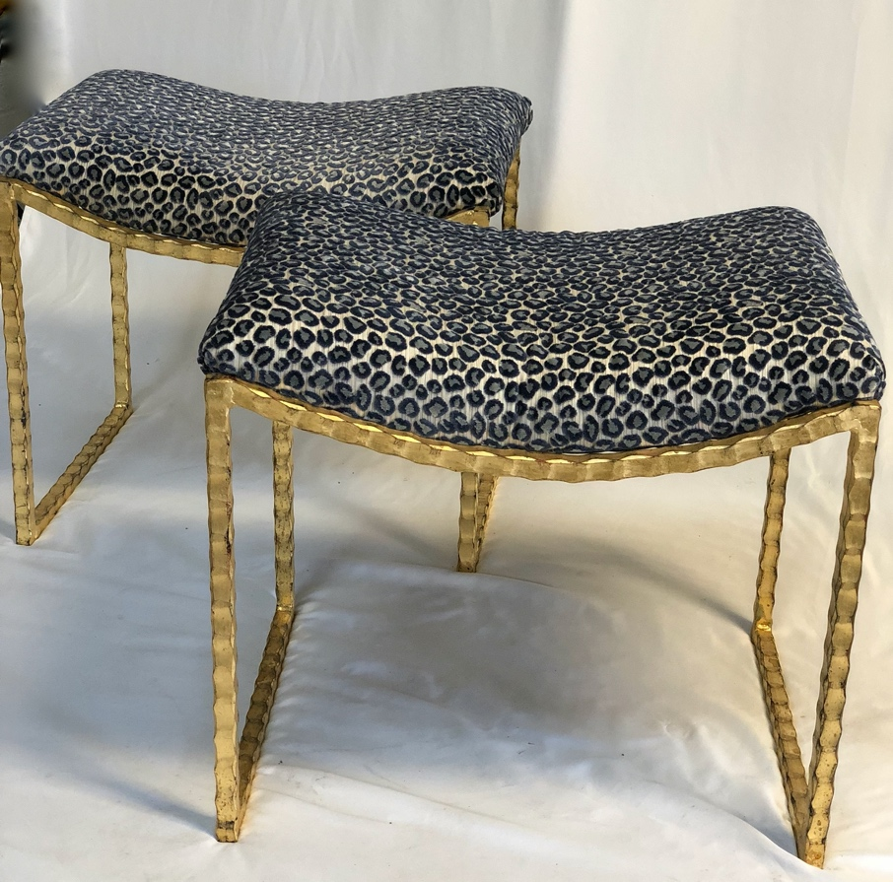

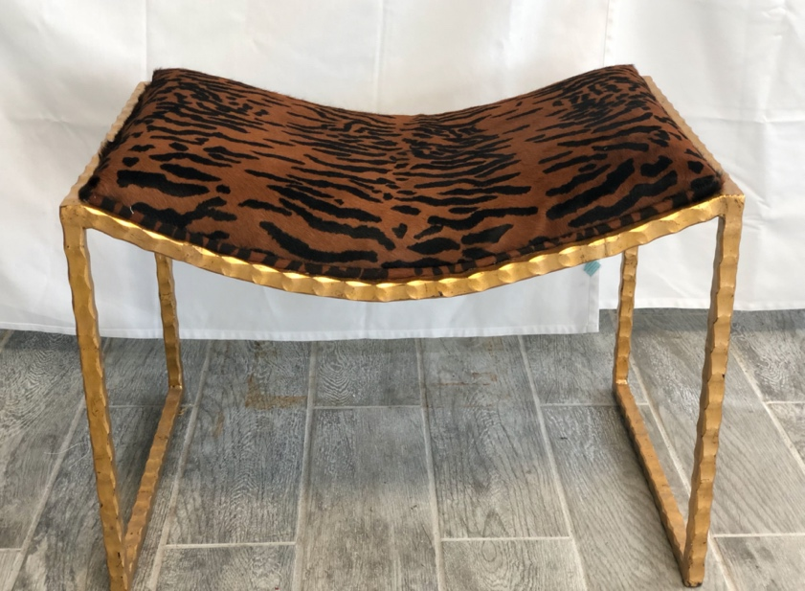

Shown in Gold Leaf, all finishes available, custom sizes available
Fabrics can be provided, COM available

3908 Magazine St. New Orleans, La. 70115 kathyslaterdesigns.com

