

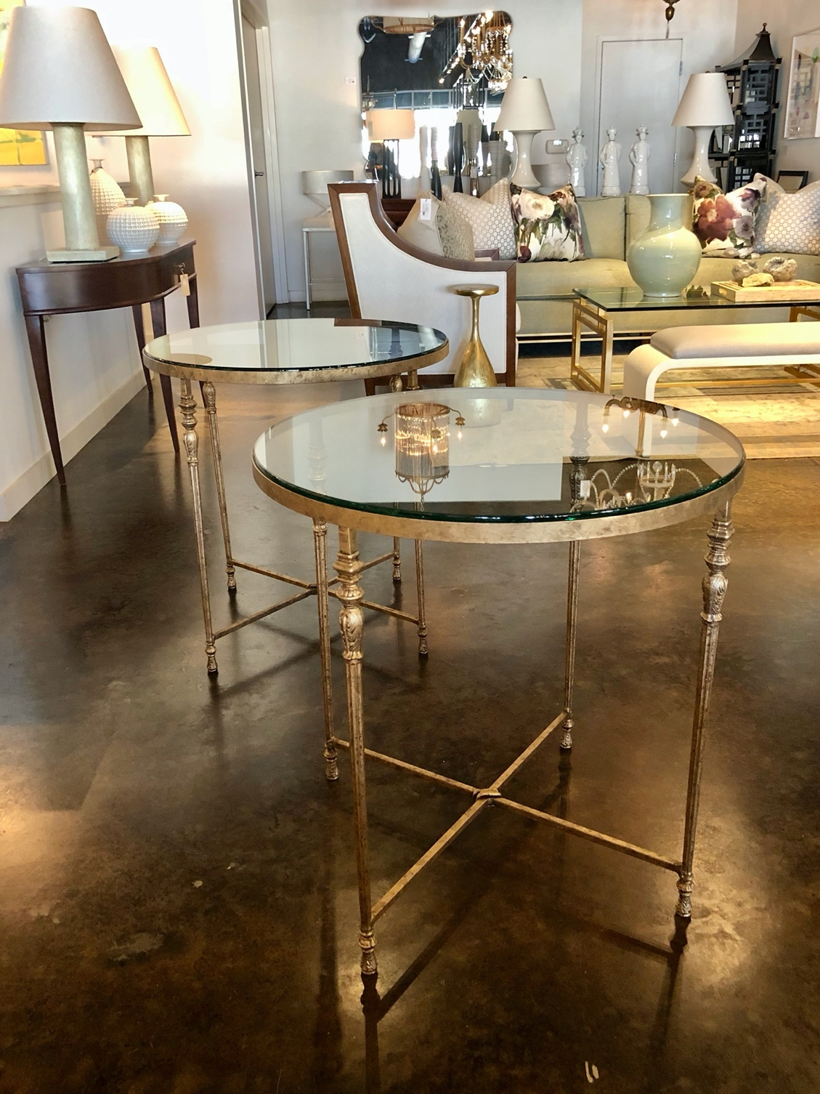

*Audubon Round Side Table*

*Shown 22” diameter , 34” high, Aged Gold Leaf finish*

*Available in custom sizes, all finishes, limestone, glass or antiqued mirror top*